Academic year 24-25
Subject: Probability and Statistics (01CT1401)
G1- A - Tutorial 1 as a part of Term work assessment

Name: Dharmik Godalka
Roll no: 92400133054
Class: 4EK1

Problem Statement:
A wholesale distributor operating in different regions of India has information on annual spending of several items in their stores across different regions and channels. The data consists of 440 large retailers’ annual spending on 6 different varieties of products in 3 different regions (Gujarat, West Bengal, Other) and across different sales channel (Hotel, Retail).
Load the Data (Just for check that data is ok):
CoDe:
import pandas as pd
import matplotlib.pyplot as plt
import seaborn as sns

df = pd.read_excel("Wholesale_customers_data.xlsx")

# Basic info abot this:
print(df.info())
print(df.describe())

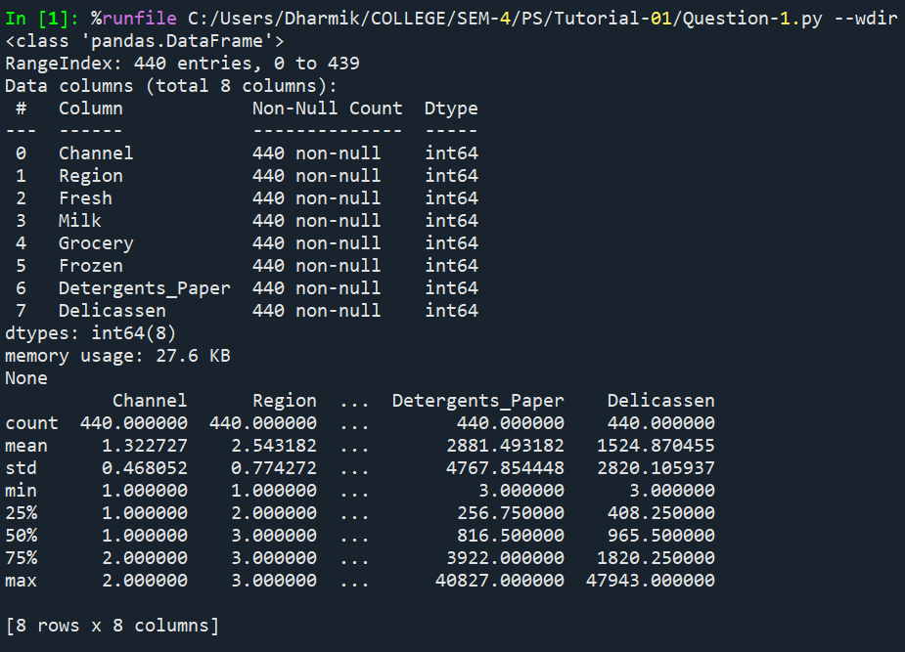
  - Use methods of descriptive statistics to summarize data. Which Region and which Channel seems to spend more? Which Region and which Channel seems to spend less?
Code:
import pandas as pd
import matplotlib.pyplot as plt
import seaborn as sns

df = pd.read_excel("Wholesale_customers_data.xlsx")

# Channel-wise:
channel = df.groupby("Channel")[["Fresh","Milk","Grocery","Frozen","Detergents_Paper","Delicassen"]].mean()
channel.plot(kind="bar")

plt.title("Channel-wise Average Spending")
plt.ylabel("Amount")
plt.xticks(rotation=0)

plt.show()

# Reigon-wise:
region = df.groupby("Region")[["Fresh","Milk","Grocery","Frozen","Detergents_Paper","Delicassen"]].mean()
region.plot(kind="bar")

plt.title("Region-wise Average Spending")
plt.ylabel("Amount")
plt.xticks(rotation=0)

plt.show()

Output:

# Channel Wise: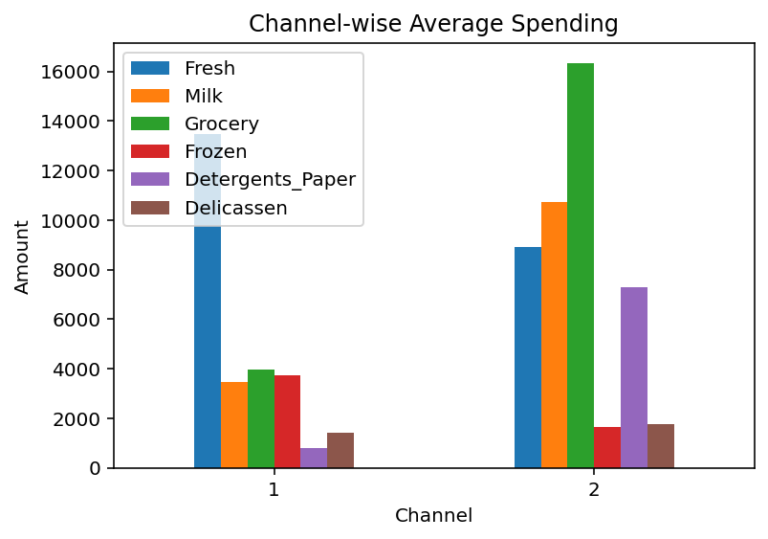

# Region Wise:
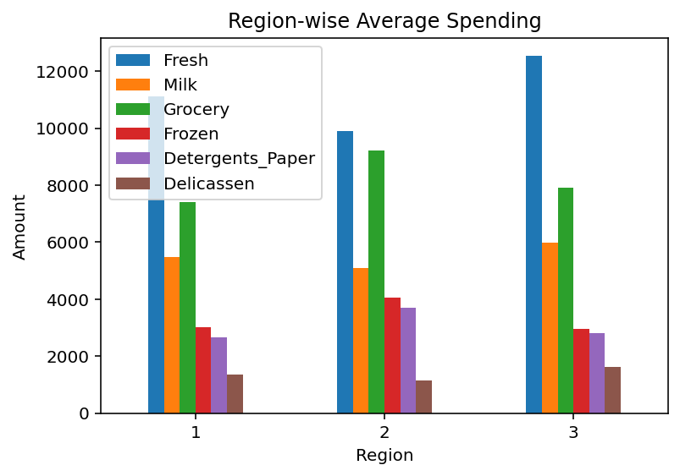

Conclusion:
The analysis shows that Retail channel (Channel 2) has higher average spending across most product categories compared to Hotel channel (Channel 1). Among the regions Region 3 records the highest spending While Region 2 spends the least. By using the mean values instead of total sums, we ensure a fair comparison between groups, since the number of retailers is not the same in each channel or region.

  - There are 6 different varieties of items are considered. Do all varieties show similar behaviour across Region and Channel?
Answer:
The graphs make it clear that the six product categories do not follow the same spending pattern across regions and channels. Each item shows a different average value Which means the bars are not equal.
For ex, Fresh has the highest spending in most regions, While Frozen and Delicassen are much lower. This proves that the behaviour of items is different so they do not show similar behaviour.

  - based on a descriptive measure of variability, which item shows the most inconsistent behaviour? Which items show the least inconsistent behaviour?
Code:
import pandas as pd
import seaborn as sns
import matplotlib.pyplot as plt

df = pd.read_excel("Wholesale_customers_data.xlsx")

# Boxplot:
plt.figure(figsize=(10,6))
sns.boxplot(data=df[["Fresh","Milk","Grocery","Frozen","Detergents_Paper","Delicassen"]])
plt.title("Item Distribution and Variability")
plt.ylabel("Spending Amount")

plt.xticks(rotation=45)
plt.show()

# Standard dev:
std = df[["Fresh","Milk","Grocery","Frozen","Detergents_Paper","Delicassen"]].std()
print("Standard Deviation of each category:\n", std)

Output(Graph):

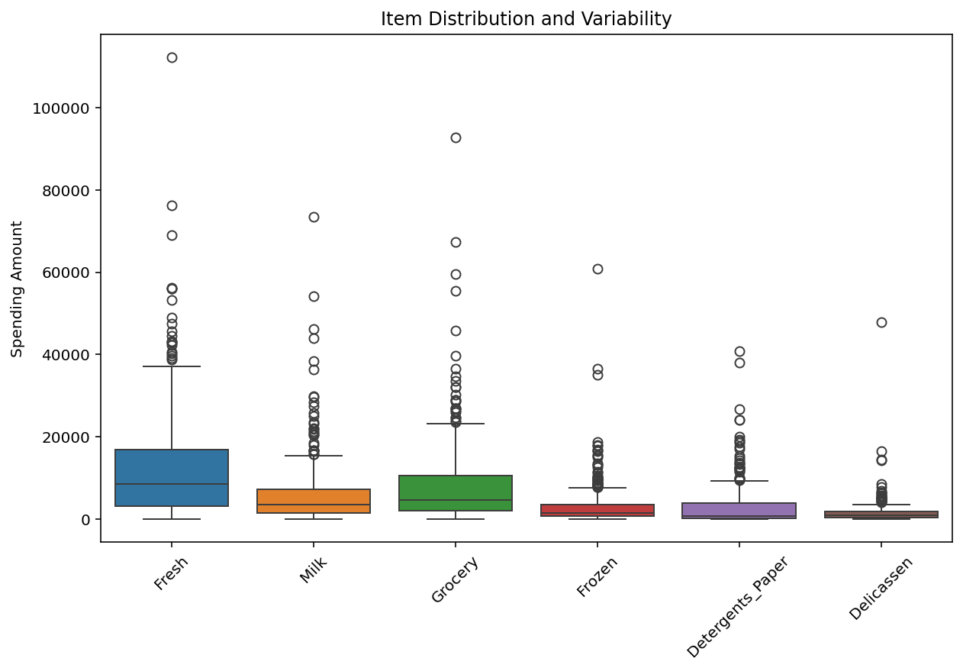

#Standard Deviation for all product:
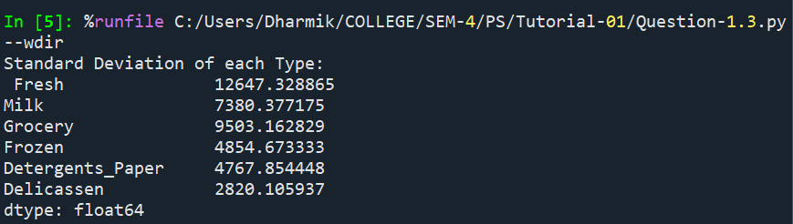

Fresh Standard dev. = 12647 highest variation most inconsistent
Delicassen Standard dev. = 2820 lowest variation most consistent
Other item (Milk, Grocery, Frozen, Detergents_Paper) is in between.
Conclusion:
The results prove that Fresh has the highest variability in spending, making it the most inconsistent item. In opposite Delicassen has the lowest variability. so it is the most consistent item. This means Fresh demand changes widely across customers while Delicassen spending remains relatively stable.

  - Are there any outliers in the data?
Code:
import pandas as pd
df = pd.read_excel("Wholesale_customers_data.xlsx")

# Outlier:
outlier = {}
for col in ["Fresh","Milk","Grocery","Frozen","Detergents_Paper","Delicassen"]:
Q1 = df[col].quantile(0.25)
Q3 = df[col].quantile(0.75)
IQR = Q3 - Q1
lower_bound = Q1 - 1.5 * IQR
upper_bound = Q3 + 1.5 * IQR
outliers = df[(df[col] < lower_bound) | (df[col] > upper_bound)][col]
outlier[col] = {
"Lower Bound": lower_bound,
"Upper Bound": upper_bound,
"Number of Outliers": outliers.count()
}

for item, values in outlier.items():
print(f"{item}:")
print(f" Lower Bound: {values['Lower Bound']}")
print(f" Upper Bound: {values['Upper Bound']}")
print(f" Number of Outliers: {values['Number of Outliers']}\n")

Output:
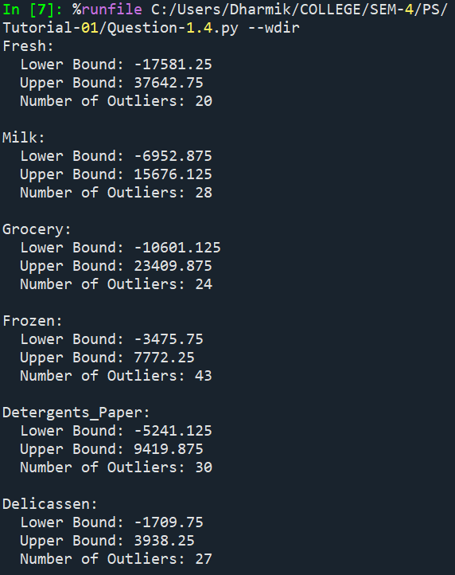
#(If we see outlier in graph its like this)
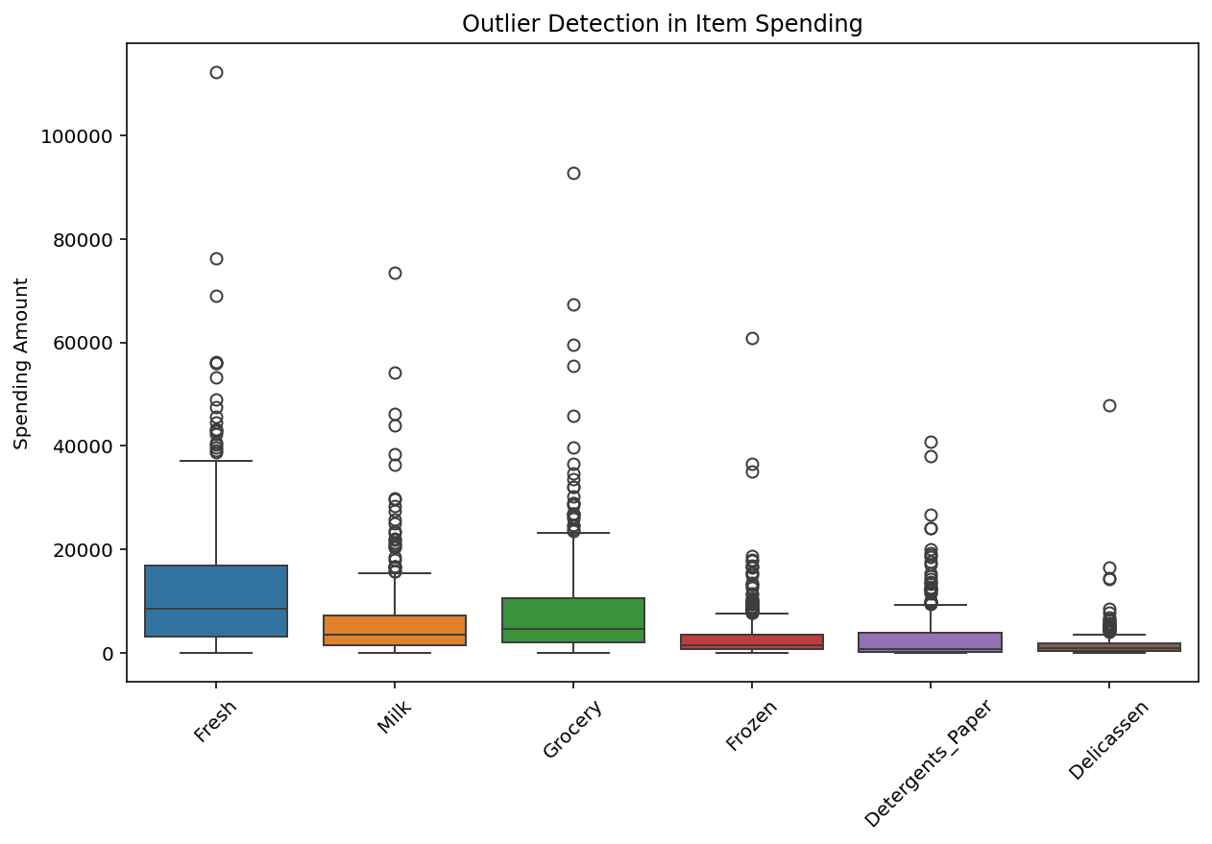
Conclusion:
The analysis confirms that outliers are present in all six categories. Among them Frozen has the highest number of outliers while other categories like Milk, Grocery, Detergents_Paper, and Delicassen also show several. These outliers represent more spending values by certain customers which may be due to differences in store size, regional demand, or transportation costs. Overall the dataset shows irregular spending behaviour with Frozen being the most affected category.

  - based on this report, what are the recommendations?
After reading this and seeing the dataset one can make this type of recommendations.

-Focus on weak areas: Region 2 and Channel 1 show lower spending. These can be improved with promotions, discounts or better product availability.

-Handle outliers smartly: Outliers are big-spending retailers. They should be identified and given loyalty programs or special offers to keep them engaged.

-Group related products in offers: Since Grocery, Milk and Detergents_Paper are linked, they can be promoted together (combo deals, shelf placement) to boost sales.
-Plan separately for independent products: Fresh, Frozen, and Delicassen don’t correlate much with others, so they need their own marketing and supply strategies.

-Seasonal planning: Products like Fresh and Frozen may depend on seasons or festivals. Adjust inventory and promotions during peak times to avoid waste.

-Improve customer experience: Simple steps like better packaging for Frozen items or easy access to Fresh products can increase demand and reduce irregularity.

Last Conclusion(For full Dataset):
This Dataset shows clear differences in spending across regions, channels, and product categories. Channel 2 and Region 3 perform best. while Region 2 and Channel 1 need improvement. Fresh requires careful inventory planning, Delicassen is stable and outliers represent valuable customers who should be retained. Overall focusing on strong areas, improving weak ones and managing products wisely can help maximise revenue.

